**COGNIZANT DIGI NURTURE 4.0**

**WEEK 1 MANDATORY HANDS ON BY (6377625)**

**DESIGN PRINCIPLES AND PATTERNS:**

**Exercise 1: Implementing Singleton Pattern**

**Program:**

I created a project named SimpleLogger and a separate Main class to verify that only one instance of Logger is created and used across the application.

**Code:**

**SimpleLogger.java**

public class SimpleLogger {  
  
 private static SimpleLogger instance;  
  
 private SimpleLogger() {  
 System.out.println("Logger Created");  
 }  
  
 public static SimpleLogger getLogger() {  
 if (instance == null) {  
 instance = new SimpleLogger();  
 }  
 return instance;  
 }  
  
 public void writeLog(String msg) {  
 System.out.println("Log: " + msg);  
 }  
}

LogMain.java

public class LogMain {  
 public static void main(String[] args) {  
 SimpleLogger log1 = SimpleLogger.getLogger();  
 log1.writeLog("First log message");  
  
 SimpleLogger log2 = SimpleLogger.getLogger();  
 log2.writeLog("Second log message");  
  
 if (log1 == log2) {  
 System.out.println("Same logger object used");  
 } else {  
 System.out.println("Different logger objects");  
 }  
 }  
}

**OUTPUT :**

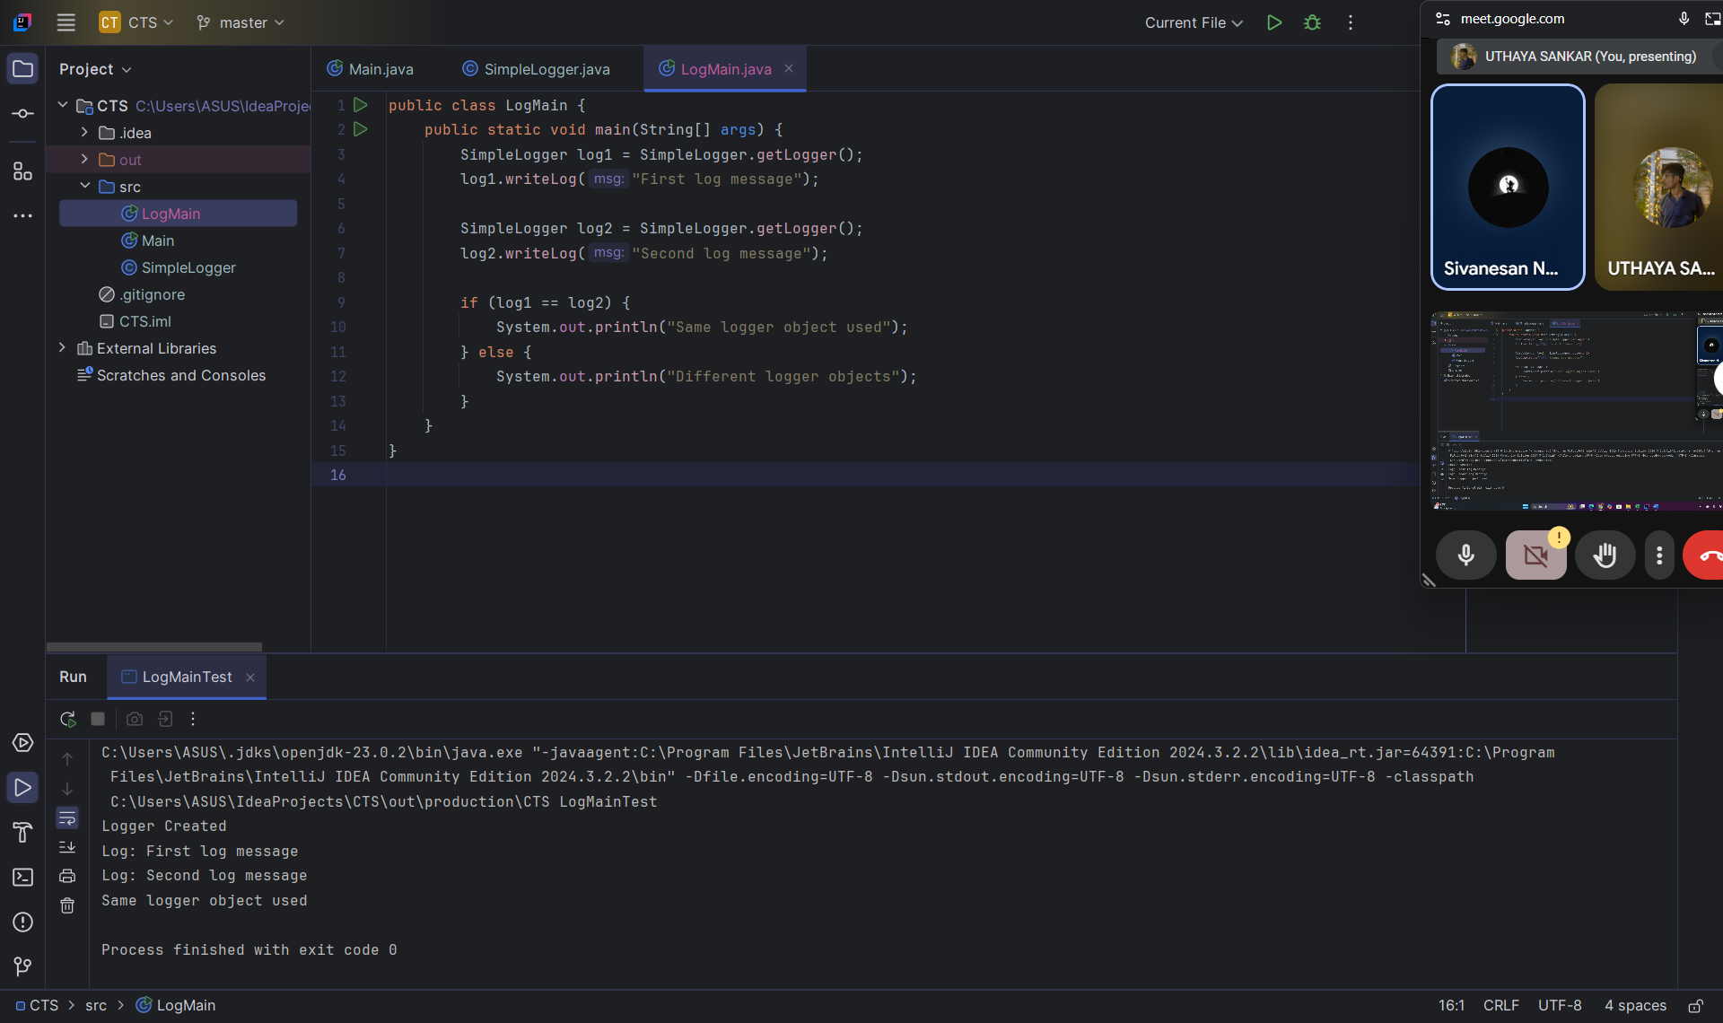

**Exercise 2:( Implementing the Factory Method Pattern)**

**Document.java:**

public interface Document {  
 void open();  
}

**WordDocument.java:**

public class WordDocument implements Document {

public void open() {

System.out.println("Opening Word Document");

}

}

**PdfDocument.java:**

public class PdfDocument implements Document {

public void open() {

System.out.println("Opening PDF Document");

}

}

**ExcelDocument.java:**

public class ExcelDocument implements Document {

public void open() {

System.out.println("Opening Excel Document");

}

}

**DocumentFactory.java:**

public abstract class DocumentFactory {

public abstract Document createDocument();

}

**WordDocumentFactory.java:**

public class WordDocumentFactory extends DocumentFactory {

public Document createDocument() {

return new WordDocument();

}

}

**PdfDocumentFactory.java:**

public class PdfDocumentFactory extends DocumentFactory {

public Document createDocument() {

return new PdfDocument();

}

}

**ExcelDocumentFactory.java:**

public class ExcelDocumentFactory extends DocumentFactory {

public Document createDocument() {

return new ExcelDocument();

}

}

**FactoryMethodPattern.java:**

public class FactoryMethodPattern {  
 public static void main(String[] args) {  
 DocumentFactory wordFactory = new WordDocumentFactory();  
 Document word = wordFactory.createDocument();  
 word.open();  
  
 DocumentFactory pdfFactory = new PdfDocumentFactory();  
 Document pdf = pdfFactory.createDocument();  
 pdf.open();  
  
 DocumentFactory excelFactory = new ExcelDocumentFactory();  
 Document excel = excelFactory.createDocument();  
 excel.open();  
 }  
}

**OUTPUT :**

